# Acceptance Criteria Testing

## Story ID 14

User Story: As a customer I want to login and store my details and have them pre-filled when creating a pickup so that I do not need to enter the same information every time I make a booking.

* When creating the booking I can select details that I used in other orders.
* When booking a new pickup my details will be automatically filled in.

When booking a new pickup my details will be automatically filled in.

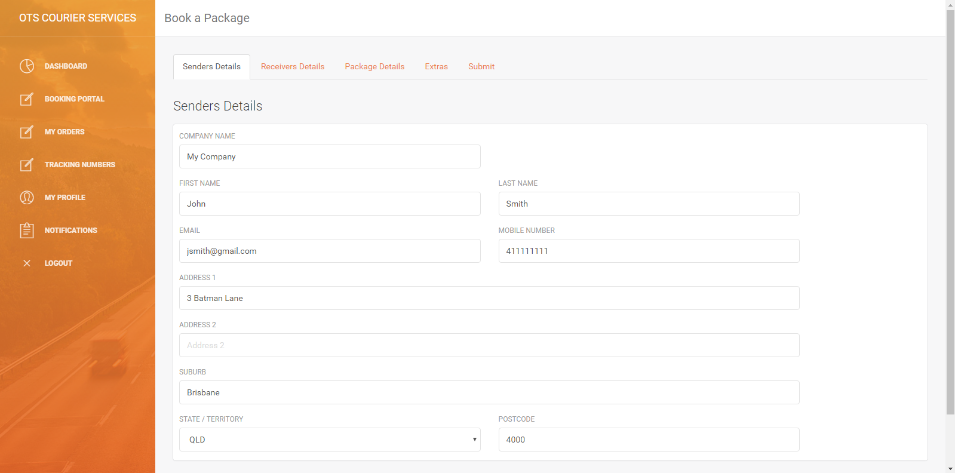

**NOT IMPLEMENTED -> When creating the booking I can select details that I used in other orders.**

This feature was continually delayed until it was cancelled altogether due to time constraints.

Jeff Jefferson is gone

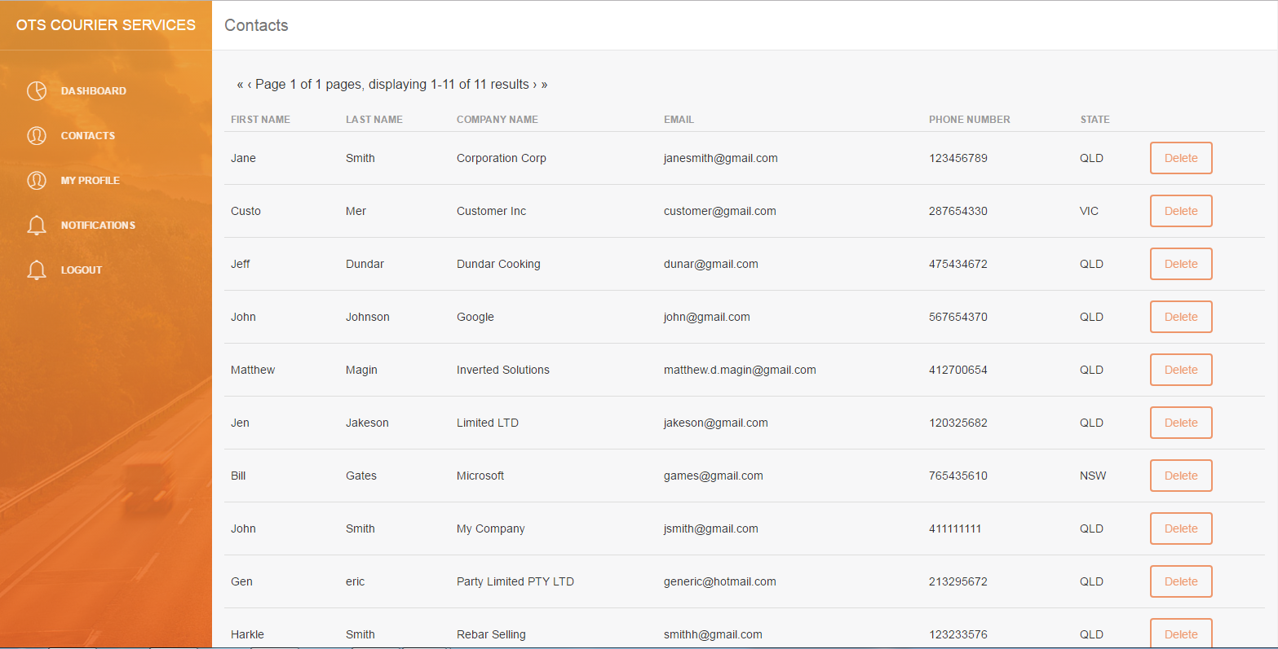

NOT IMPLEMENTED → ADD CONTACT

During development, it was found since the current iteration of the contacts page draws from the customers table and adding a contact would effectively create an account for them (complete with a password) either this function needs to be available to the customers themselves or be retooled to use a different table.